**Project Report**

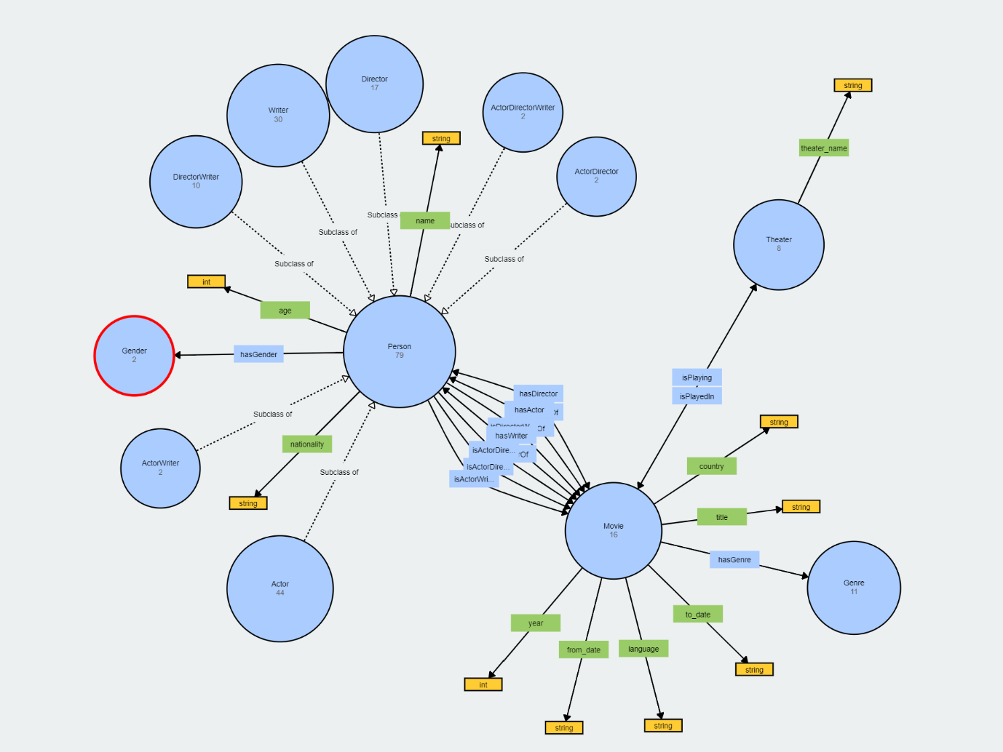

* 5 classes : *Movie, Person, Genre, Theater* and *Gender*
* 10 data type properties : *theater_nmae, age, nationality, name, year, from_date, to_date, language, title* and *country*
* 14 object type properties : *hasActor, hasDirector, hasGender, hasGenre, hasWriter, isActorDirectorOf, isActorDirectorWriterOf, isActorOf, isActorWriterOf, isDirectorOf, isDirectorWriterOf, isPlayedIn, isPlaying* and *isWriterOf*

**Choices :** we decided to have *Genre* and *Gender* as classes and not data type properties because we needed to have certain specific values (for example, in *Gender*, only ‘male’ and ‘female’ are accepted values).

Each object type properties between *Movies* and *Person* have an inverse ; for example, *hasActor* and *isActorOf*. Same for *isPlayedin* and  *isPlaying* for *Movies* and *Theater*.

For the data type properties, we just followed what was asked in the subject of the project.

For *from_date* and *to_date* properties, we decided to use string and not date_time to avoid any error due to a format error. Plus, we didn’t use these properties in our project, so it is not a problem.